10 Linux Commands
1. groupadd — Create a new group
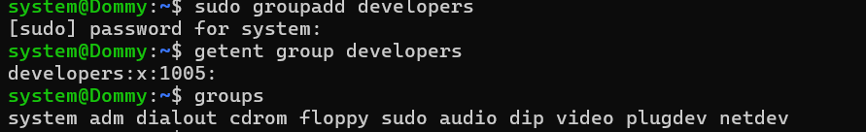
2. groups — Display group membership
3. groupmod — Modify a group
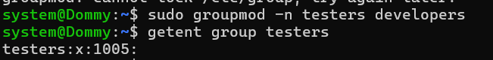
4. gpasswd — Manage group membership
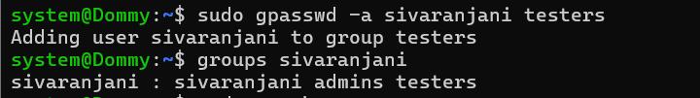
5. groupdel — Delete a group
6. chrt — Display or modify scheduling policy
7. mpstat — Display CPU statistics
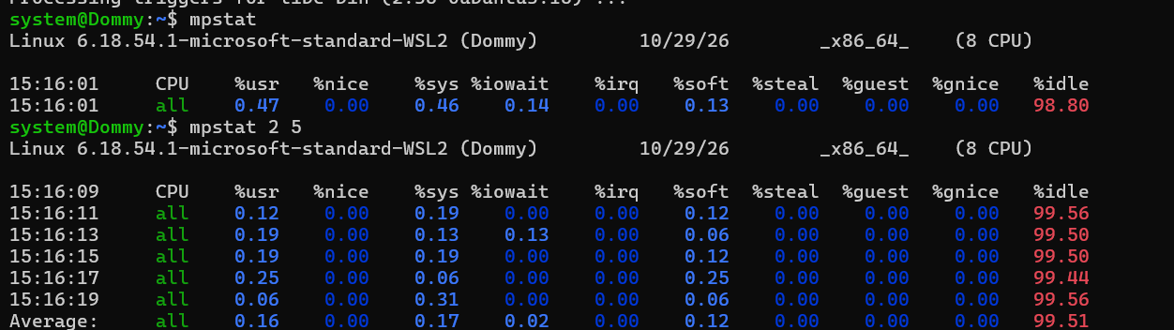

8. pmap — Display process memory usage
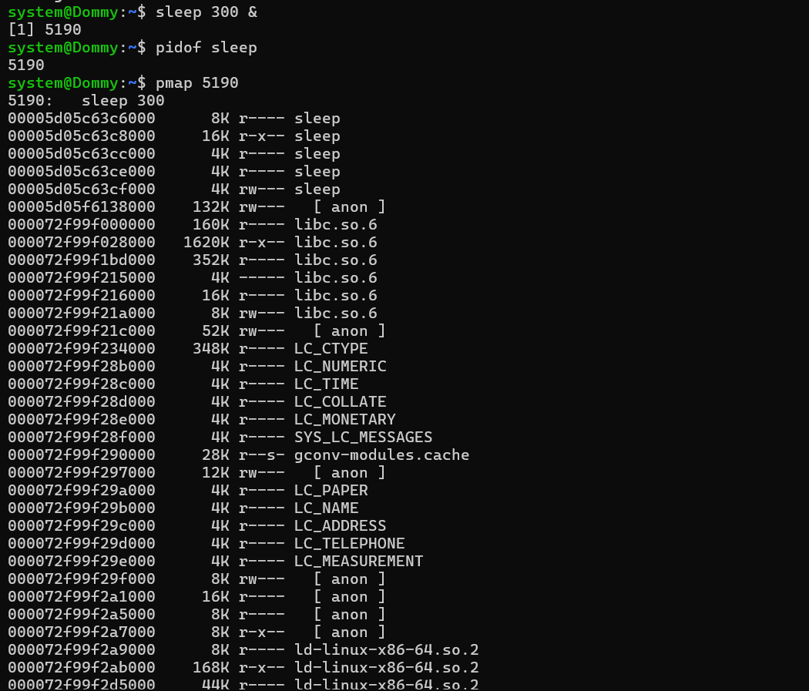
9. scp — Copy a file
10. rsync — Synchronize directories
